Website Idea: daily fun surveys
>> Each day of the year, there is a new survey with questions such as, what is the best movie of all time?
>> Everyone can enter one answer per day.
>> After the survey is completed, the user can see results in all the different forms of graphs.

Resources used:
>> HTML – structure of the page
>> CSS – make it look nice
>> JavaScript – make it interactive
>> SQL – store the data
>> Python – create the charts/graphs
>> AWS - hosting

Feature List:
>> Accounts: allows the user to log their survey answers to their account and provides access to past survey results. Also has a leveling system depending on the number of surveys the user has participated in.
>> Auto complete: When a user is typing an answer, a box will pop up suggesting an already submitted result. Example: someone enters star wars as their favorite movie. A box will then pop up saying did you mean Star Wars: A New Hope?
>> Graphs contain all demographics such as gender, race, religion, wealth, age, and these graphs/charts can be sorted by the user. For example, if they want to see results based on race, they could toggle it in a drop down menu.

Wireframes:
Home page
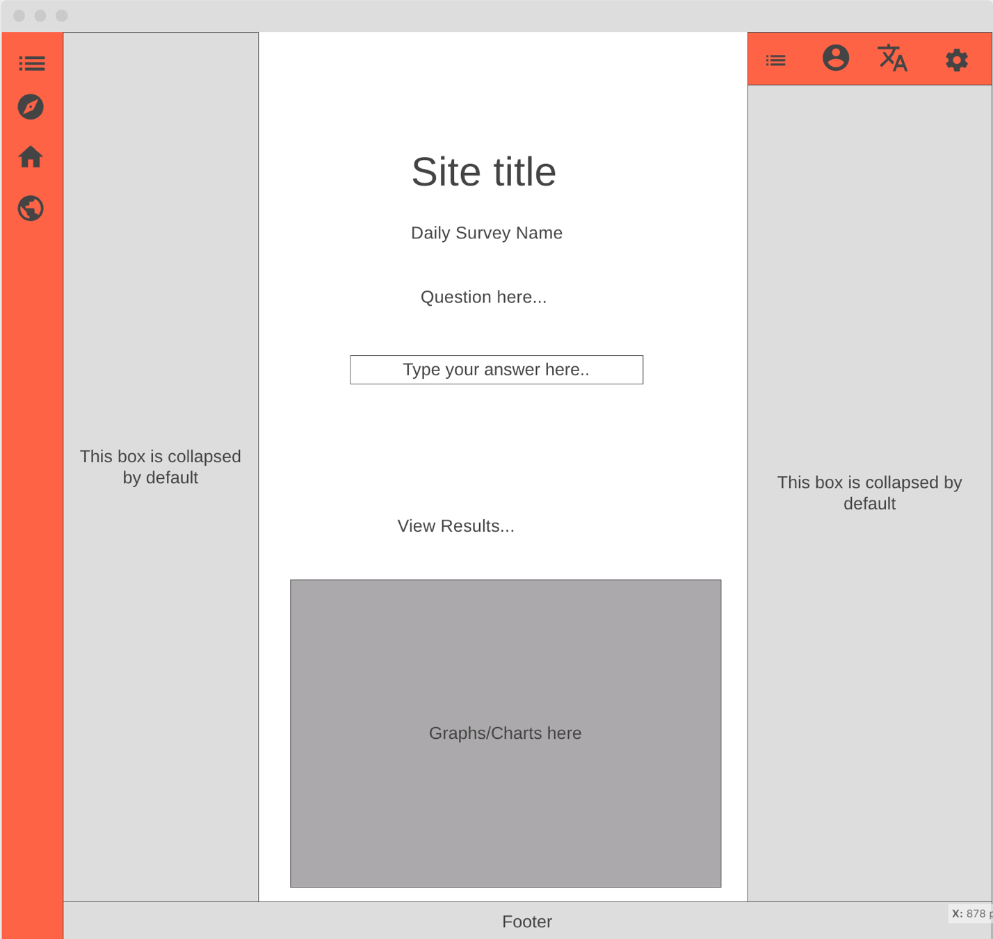

Results page:
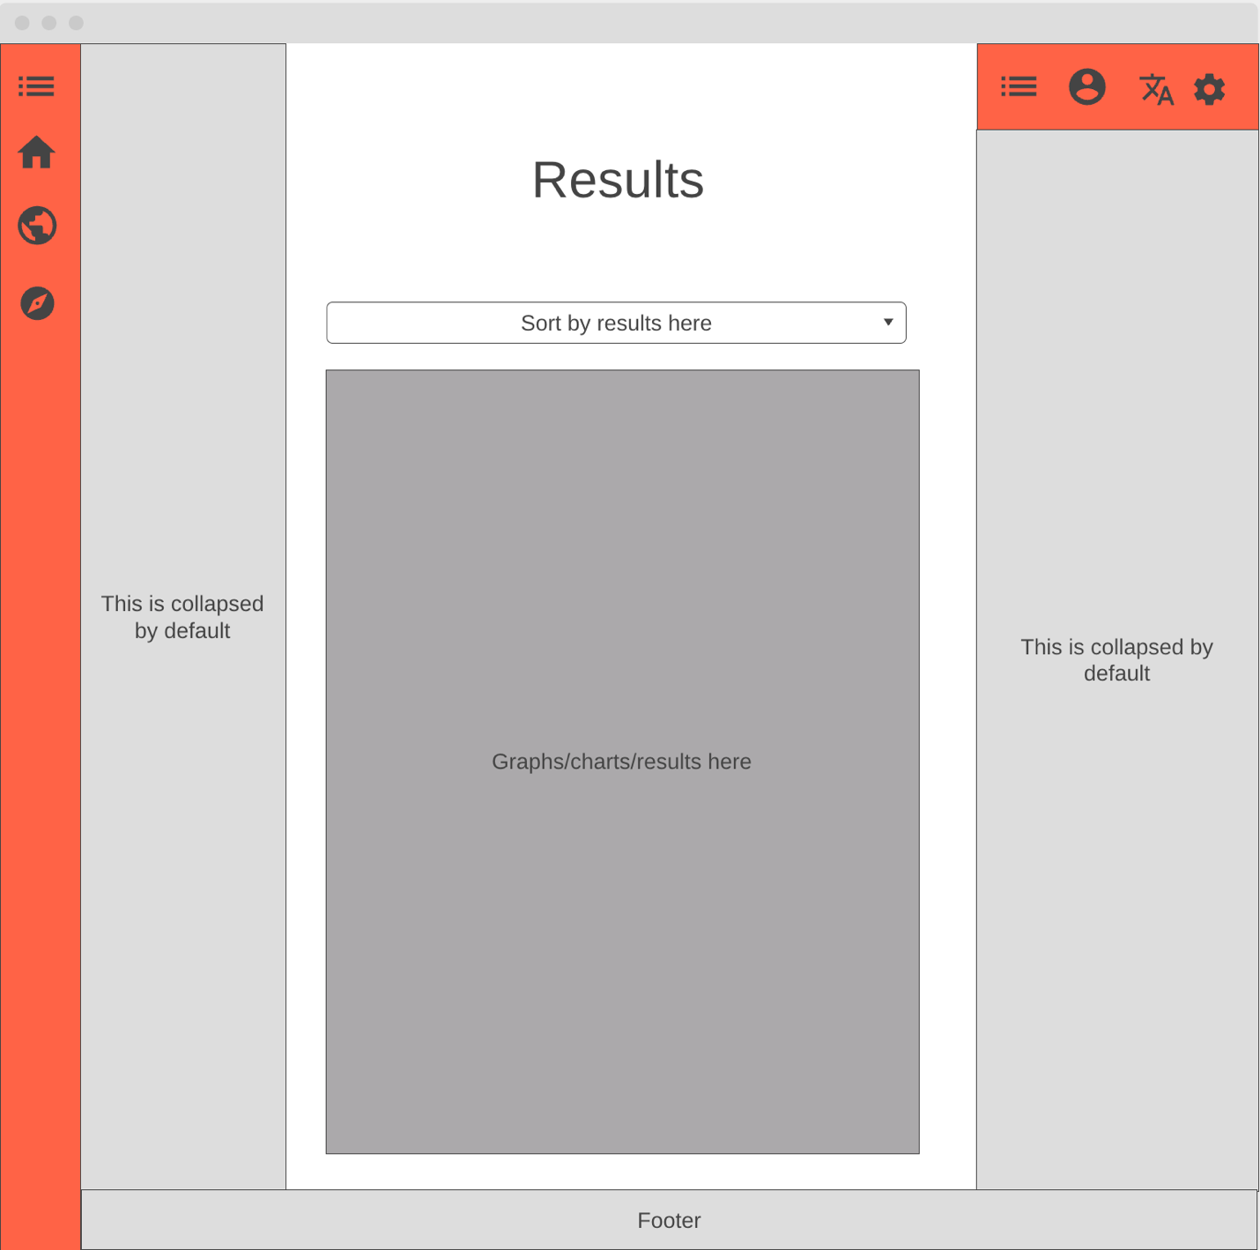

VERSION #1
Steps:
Phase #1)
>> Write list of “must haves” vs “can be done laters”
>> Create a wireframe for the schema
Phase #2)
>> Set up GitHub repo and base files
>> Build home page in HTML & CSS along with a hardcoded test question
>> Create schema in MySQL
Phase #3)
>> Use either Node.js or Python to code the connection between the schema and the site
>> Use JS to capture an answer, send it to the server, then stores answer while enforcing one a day rule
>> Build results view. Pull stored answers, aggregate them, and have Python make a chart
Phase #4)
>> Style and polish the site
>> Deploy to AWS

PHASE #1:
Must Haves: One survey per day, Results page with bar chart
Laters: Accounts, Streaks, “did you mean..?”

Database Schema:
Allow users to submit an answer to a question and also fill out their demographics and then have that information be stored in a different table per day
Nouns (Tables): User, answer, question, demographics, day
Attributes:
User = user id, username, age, gender, race, religion, income level, country, state, education level
Answer = answer id, answer text, user id, question id, time submitted
Question = question id, question text, date posted, is active (true or false)
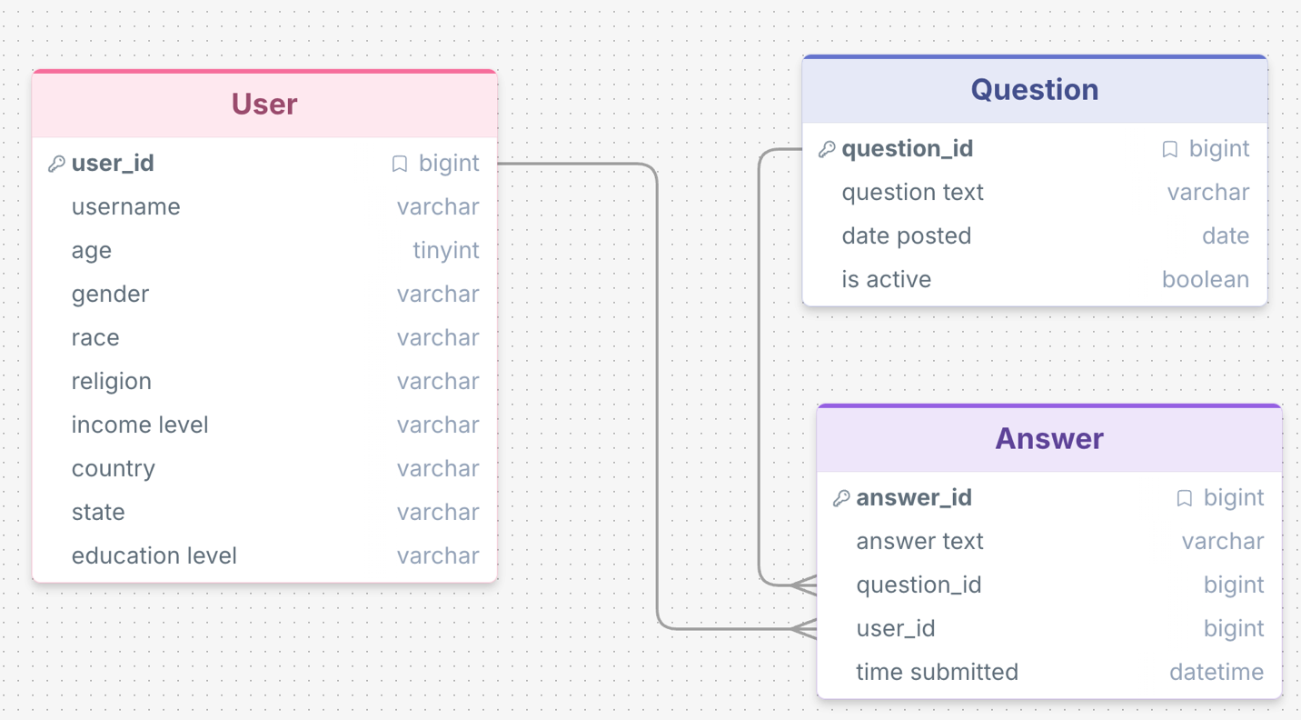

PHASE #2:

